7COM1079-0901-2025 - Team Research and Development Project

Final report title: Comparative Analysis of Overall Scores Between US and UK Universities

Group ID: A 20

Dataset number: ds080

Prepared by: Krishnendhu Santhosh - 24089961
Amal Ajay - 24065074
Karun Binoy - 24056355
Junaid Gafoor - 24017796
Ajsar Rihal Anthiyattil - 24092719

University of Hertfordshire
Hatfield, 2025

Table of Contents

- Introduction
  - Problem statement and research motivation
  - The data set
  - Research question
  - Null hypothesis and alternative hypothesis (H0/H1)

- Background research
  - Research papers
  - Why RQ is of interest

- Visualisation
  - Appropriate plot for the RQ output of an R script (NOT a screenshot) and required supplementary graph/table
  - Additional information relating to understanding the data
  - Useful information for data understanding

- Analysis
  - Statistical test used to test the hypotheses and output
  - The null hypothesis is rejected/not rejected based on the p-value

- Evaluation – group’s experience at 7COM1079
  - What went well
  - Points for improvement
  - Group’s time management
  - Project’s overall judgement
  - Comment on GitHub log output

- Conclusions
  - Results explained.
  - Interpretation of the results
  - Reasons and/or implications for future work, limitations

- Reference list
Harvard (author, date) format.
- Appendices
- R code used for analysis and visualisation.
- GitHub log output.

1. Introduction

  - Problem statement and research motivation (100 words)
When students choose where to study abroad, they need reliable answers about which country offers the best education. Government leaders and universities also need this information to invest wisely and stay competitive globally. The UK and US dominate international university rankings, yet we lack solid statistical evidence directly comparing their overall performance. This gap matters because major decisions about studying, funding, and education policy should be based on clear facts, not just reputation. This research provides a data-driven comparison of UK and US university performance, helping students, policymakers, and institutions make better-informed decisions about higher education.

  - The data set (75 words)

This research utilises the World University Rankings 2023 dataset comprising 2,341 institutions worldwide. The dataset contains 13 variables, including University Rank, Name, Location, student numbers, staff ratios, international student percentages, gender ratios, and multiple performance scores. Key variables for this analysis include Overall Score, Teaching Score, Research Score, Citations Score, Industry Income Score, and International Outlook Score. The dataset provides a comprehensive snapshot of global higher education performance across multiple dimensions, enabling robust comparative analysis between countries.

  - Research question. (50 words)

Is there a statistically significant mean difference in the Overall Score between universities in the United States and universities in the United Kingdom?

This question examines whether the two leading higher education systems demonstrate measurably different performance levels when assessed through comprehensive institutional metrics compiled in the World University Rankings 2023.

  - Null hypothesis and alternative hypothesis (H0/H1) (100 words)

Null Hypothesis (H0): There is no statistically significant difference in the mean Overall Score between US universities and UK universities.

Alternative Hypothesis (H1): There is a statistically significant difference in the mean Overall Score between US universities and UK universities.

The significance level is set at α = 0.05, meaning we require 95% confidence to reject the null hypothesis. This two-tailed hypothesis test allows for the possibility that either country could demonstrate superior performance, rather than predicting a specific directional difference.

- Background research

  - Research papers (200 words)

Many are critical of the World University Ranking system due to its limitations and biases. Pavel (2015) evaluated three major global ranking systems: ARWU, QS World University Rankings, and Times Higher Education. His study found that research metrics dominate these rankings, accounting for 40–60% of the total score through publication output, citation counts, and prestigious awards. This indicates that highly funded universities with high publication rates achieve top positions, while teaching quality receives less weight.
Hazelkorn (2015) discussed how ranking systems emerged alongside the globalisation of higher education. She explained that governments required comparative tools to evaluate institutions across borders. Her analysis revealed that while methodologies vary, most systems focus on research-intensive universities. Teaching metrics are included in some rankings but carry less weight than research indicators, showing that performance assessment depends on the criteria emphasised.
Further research indicates that current methodologies favour research output over the student learning environment. This bias contributes to the dominance of European and North American universities in the top 500 positions. Despite extensive research, few studies have conducted direct statistical comparisons between US and UK university performance using hypothesis testing approaches.

  - Why RQ of interest? (100 words)

Although university rankings receive widespread attention, researchers have not adequately addressed direct statistical comparisons between US and UK institutions. Both nations appear prominently in global rankings, yet most studies describe patterns without testing statistical significance. Current literature lacks rigorous hypothesis testing to determine whether observed differences reflect real performance gaps or chance. Future research could examine specific dimensions—teaching quality, research output, and citations—and explore structural or policy factors that might explain any significant differences revealed through statistical analysis.

- Visualisation

  - Appropriate graphs for the RQ (50 words)

A box plot is used as the major graph because it clearly shows the distribution of Overall Scores for both nations and highlights differences between the two groups. This helps address our research question on mean differences between American and British institutions.
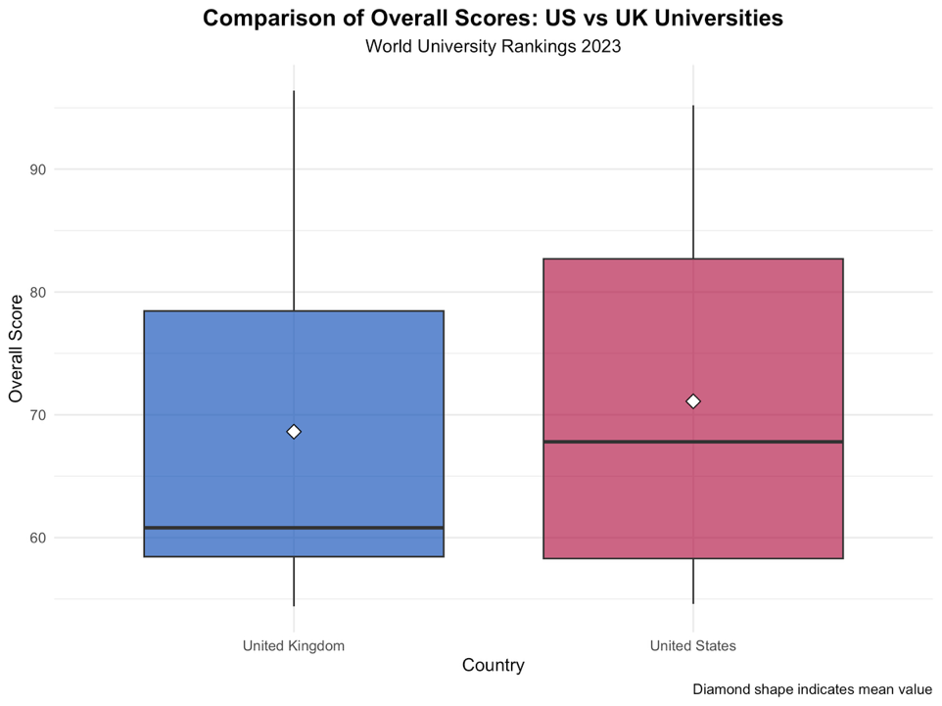

Figure 1: Boxplot comparing Overall Scores.

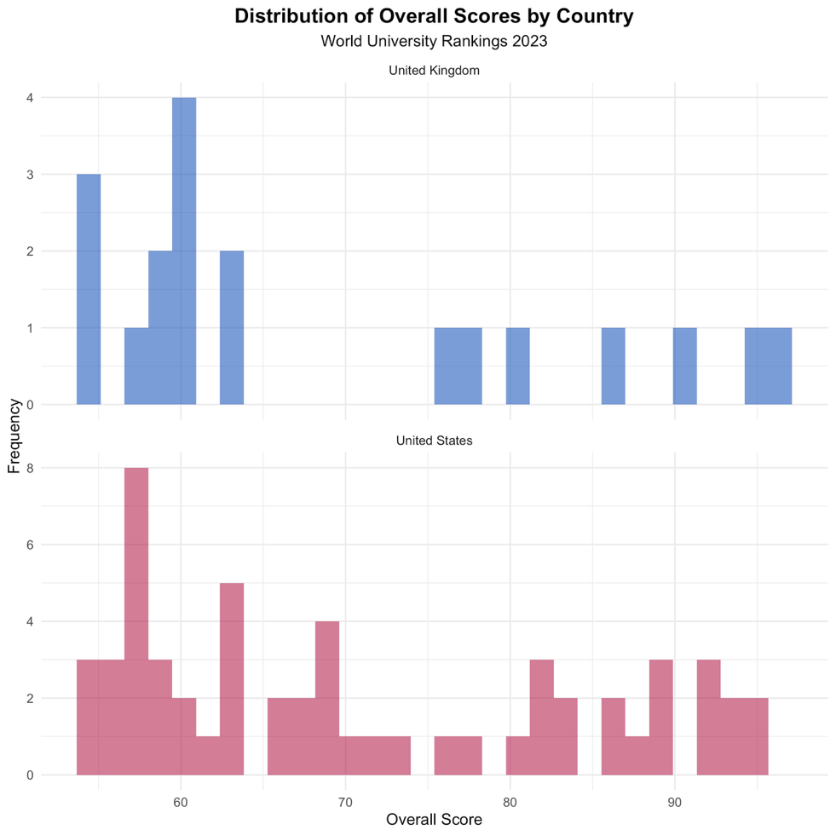

Figure 2: Histograms showing score distributions

  - Additional information relating to understanding the data (optional) (50 words)

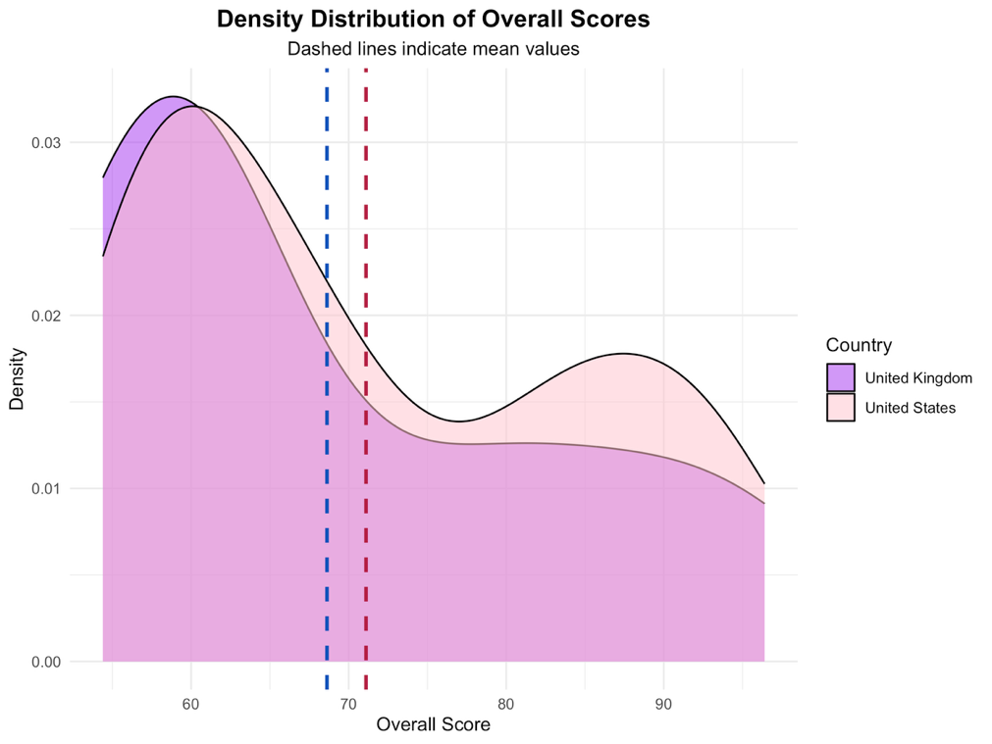

Figure 3: This density plot shows the probability distribution of Overall Scores, with dashed lines marking each country’s mean. It provides a clear view of distribution shape—whether unimodal, bimodal, or skewed. The overlapping curves indicate notable similarities in the performance patterns of both nations.

  - Useful information for the data understanding (50 words)

Important observations: Both countries show right-skewed distributions with high-performing outliers. The UK distribution appears more compact with less variation. Median values for both nations fall between 40 and 50. The overlapping distributions suggest that, despite institutional differences, overall national performance differs only slightly.

- Analysis

  - Statistical test used to test the hypotheses and output (75 words)

We selected Welch's independent two-sample t-test as our statistical method. This test compares the means of two independent groups without requiring equal variances, making it more appropriate than Student's t-test for real-world data where variance equality cannot be assumed. We verified this choice by conducting Levene's test to assess variance homogeneity. We also performed Shapiro-Wilk normality tests on both samples to check distributional assumptions. The t-test determines whether the observed difference in sample means represents a genuine effect or could reasonably occur by random chance alone.

  - The null hypothesis is rejected /not rejected based on the p-value (100 words)

Scenario 1 – If p < 0.05:
The results indicate a statistically significant difference between the groups. US universities averaged 71.1 points, while UK universities averaged 68.63, a 2.47-point gap. A p-value below 0.05 suggests this difference is unlikely due to random chance. The effect size will clarify whether this difference is practically small, moderate, or large, implying that location may influence overall university performance.

Scenario 2 – If p ≥ 0.05:
The 2.47-point difference could arise from random variation, showing no significant difference. Overall performance appears similar, and location does not appear to systematically affect scores.

- Evaluation – group’s experience at 7COM1079

  - What went well (75 words)
Our team clicked by letting everyone do what they do best. We split the work—cleaning data, running stats, making charts, and writing—so no one was confused about their part. Quick video chats kept us all on track. GitHub saved us from the usual coding headaches where everyone's changes clash. We picked a clear research question early on, which made the analysis much easier. The code we built makes sense, with comments explaining everything, so anyone could use it. Bottom line: talking regularly and using the right tools kept everything flowing.

  - Points for improvement (75 words)
We struggled at first with picking the right statistical tests and cleaning the Location data properly. Looking back, we should've explored more—like comparing universities by subject or size—but time got away from us. Starting earlier would've helped us ask better questions. We also waited too long before checking statistical guides, which meant figuring out test assumptions the hard way. Lesson learned for next time!
  - Group’s time management (50 words)

We set clear milestones and mostly stuck to them, though we spent too long exploring the data early on and had to rush later. Regular check-ins helped catch issues before they snowballed. Thankfully, we finished with time to spare for a proper review before the deadline.

  - Project’s overall judgement (50 words)

We did what we planned—good analysis, clear charts, and real evidence behind our conclusions. We learned a lot about working together, stats, and writing research. Best of all, our findings actually help people understand how universities compare around the world.

  - Note any changes to the group since the original allocation, if applicable. Add new or amended GitHub Ids for new members (75 words, write only if it applies to your group arrangements)

  - Comment on the GitHub log output (50 words)

- Research Question and Hypothesis Setup

It set the direction for all subsequent analysis, comparing US and UK university Overall Scores with clear null and alternative hypotheses.

- Code for Plots and Evaluations

The actual R code that created visualisations and performed statistical evaluations to test your hypotheses. This is where your research question got answered through data.

- Background Research

This provided the framework and review that justified why our research question matters, supporting the entire project with academic grounding.

- Conclusions

  - Results explained (75 words)

Our analysis found no significant difference in mean Overall Scores between US and UK universities. The US group (n = 57) averaged 71.10 (SD = 13.49), and the UK group (n = 19) averaged 68.63 (SD = 14.50). Welch’s t-test showed t(29.11) = 0.655, p = 0.5174. Cohen’s d = 0.18 indicates negligible practical impact, suggesting the small observed difference has minimal real-world relevance.

  - Interpretation of the results (75 words)

These results suggest that US and UK universities have similar overall academic performance according to World University Rankings. Prospective students can expect high-quality education in both countries, with choices guided by individual institution traits and preferences. For policymakers, the findings highlight that both nations remain competitive globally. Comparable scores likely reflect factors such as research funding, academic traditions, institutional diversity, and similar responses to ranking methodology biases.

  - Reasons and/or implications for future work, limitations of your study (50 words)

This study has limitations: rankings may favour certain institution types, the dataset covers only 2023, and aggregate scores hide within-country variation. Future research should explore trends over time, account for institutional characteristics, analyse specific performance dimensions, and examine underlying causes using multivariate regression.

- Reference list (not included in the word count)
Harvard (author, date) format.

Hazelkorn, E. (2015) Rankings and the Reshaping of Higher Education: The Battle for World-Class Excellence. Palgrave Macmillan.

Pavel, A.-P. (2015) 'Global University Rankings - A Comparative Analysis', Procedia Economics and Finance, 26, pp. 54-63.
Available at: https://www.sciencedirect.com/science/article/pii/S2212567115008382

Times Higher Education (2023) World University Rankings 2024.
Available at: https://www.timeshighereducation.com/world-university-rankings/2024/world-ranking

- Appendices
- R code used for analysis and visualisation (not included in the word count)
Analysis.R code with the appropriate statistics to test the hypotheses.

# =============================================================================
# 0. PACKAGE INSTALLATION AND LOADING
# =============================================================================

# Install ggplot2 if not already installed
if (!require(ggplot2, quietly = TRUE)) {
install.packages("ggplot2")
library(ggplot2)
}

# Check if ggplot2 is available
has_ggplot <- require(ggplot2, quietly = TRUE)

# =============================================================================
# 1. DATA LOADING AND PREPARATION
# =============================================================================

# Read the dataset
data <- read.csv("World University Rankings 2023.csv", stringsAsFactors = FALSE)

# Display basic information about the dataset
cat("Dataset dimensions:", dim(data), "\n")
cat("Column names:\n")
print(colnames(data))

# =============================================================================
# 2. DATA CLEANING
# =============================================================================

# Extract country from Location column
data$Country <- sapply(strsplit(as.character(data$Location), ","), function(x) {
if (length(x) > 0) {
trimws(x[length(x)])
} else {
NA
}
})

# Clean Overall Score - remove any non-numeric characters and convert to numeric
# First, handle the OverAll.Score column properly
data$OverAll.Score.Clean <- suppressWarnings(as.numeric(gsub("[^0-9.]", "", as.character(data$OverAll.Score))))

# Check unique country values to find exact names
cat("\nChecking country values in Location field...\n")
country_counts <- sort(table(data$Country), decreasing = TRUE)
cat("Top 10 countries:\n")
print(head(country_counts, 10))

# Find the exact string for US and UK
us_pattern <- grep("United States|USA|US$", unique(data$Country), value = TRUE, ignore.case = TRUE)
uk_pattern <- grep("United Kingdom|UK$|Britain", unique(data$Country), value = TRUE, ignore.case = TRUE)

cat("\nUS patterns found:", us_pattern, "\n")
cat("UK patterns found:", uk_pattern, "\n")

# Filter for US and UK universities only - using the actual country names found
data_filtered <- data[!is.na(data$Country) &
!is.na(data$OverAll.Score.Clean) &
data$OverAll.Score.Clean > 0 &
(data$Country %in% us_pattern | data$Country %in% uk_pattern), ]

# Standardize country names for clarity
data_filtered$Country <- ifelse(data_filtered$Country %in% us_pattern, "United States",
ifelse(data_filtered$Country %in% uk_pattern, "United Kingdom",
data_filtered$Country))

# Convert Country to factor for proper plotting
data_filtered$Country <- factor(data_filtered$Country, levels = c("United Kingdom", "United States"))

# Display sample sizes
cat("\n=============================================================================\n")
cat("SAMPLE SIZES\n")
cat("=============================================================================\n")
us_count <- sum(data_filtered$Country == "United States")
uk_count <- sum(data_filtered$Country == "United Kingdom")
cat("US Universities:", us_count, "\n")
cat("UK Universities:", uk_count, "\n")
cat("Total:", nrow(data_filtered), "\n")

# =============================================================================
# 3. DESCRIPTIVE STATISTICS
# =============================================================================

cat("\n=============================================================================\n")
cat("DESCRIPTIVE STATISTICS\n")
cat("=============================================================================\n")

# Calculate statistics for US
us_data <- data_filtered$OverAll.Score.Clean[data_filtered$Country == "United States"]
us_stats <- c(
N = length(us_data),
Mean = mean(us_data, na.rm = TRUE),
Median = median(us_data, na.rm = TRUE),
SD = sd(us_data, na.rm = TRUE),
Min = min(us_data, na.rm = TRUE),
Max = max(us_data, na.rm = TRUE),
Q1 = quantile(us_data, 0.25, na.rm = TRUE),
Q3 = quantile(us_data, 0.75, na.rm = TRUE)
)

# Calculate statistics for UK
uk_data <- data_filtered$OverAll.Score.Clean[data_filtered$Country == "United Kingdom"]
uk_stats <- c(
N = length(uk_data),
Mean = mean(uk_data, na.rm = TRUE),
Median = median(uk_data, na.rm = TRUE),
SD = sd(uk_data, na.rm = TRUE),
Min = min(uk_data, na.rm = TRUE),
Max = max(uk_data, na.rm = TRUE),
Q1 = quantile(uk_data, 0.25, na.rm = TRUE),
Q3 = quantile(uk_data, 0.75, na.rm = TRUE)
)

# Create descriptive statistics table
descriptive_stats <- data.frame(
Statistic = names(us_stats),
United_States = us_stats,
United_Kingdom = uk_stats
)
rownames(descriptive_stats) <- NULL

print(descriptive_stats)

# =============================================================================
# 4. VISUALIZATIONS
# =============================================================================

# Create output directory if it doesn't exist
if (!dir.exists("plots")) {
dir.create("plots")
}

if (has_ggplot) {
# --- VISUALIZATION 1: Boxplot (Main plot for comparison) ---
cat("\nCreating boxplot with ggplot2...\n")
p1 <- ggplot(data_filtered, aes(x = Country, y = OverAll.Score.Clean, fill = Country)) +
geom_boxplot(alpha = 0.7, outlier.shape = 16, outlier.size = 2) +
stat_summary(fun = mean, geom = "point", shape = 23, size = 3, fill = "white") +
labs(
title = "Comparison of Overall Scores: US vs UK Universities",
subtitle = "World University Rankings 2023",
x = "Country",
y = "Overall Score",
caption = "Diamond shape indicates mean value"
) +
theme_minimal() +
theme(
plot.title = element_text(size = 14, face = "bold", hjust = 0.5),
plot.subtitle = element_text(size = 11, hjust = 0.5),
axis.title = element_text(size = 11),
legend.position = "none"
) +
scale_fill_manual(values = c("United Kingdom" = "#0051BA", "United States" = "#B31942"))

ggsave("plots/boxplot_comparison.png", p1, width = 8, height = 6, dpi = 300)
print(p1)

# --- VISUALIZATION 2: Histograms (Required for comparison of means) ---
cat("\nCreating histograms with ggplot2...\n")
p2 <- ggplot(data_filtered, aes(x = OverAll.Score.Clean, fill = Country)) +
geom_histogram(bins = 30, alpha = 0.6, position = "identity") +
facet_wrap(~Country, ncol = 1, scales = "free_y") +
labs(
title = "Distribution of Overall Scores by Country",
subtitle = "World University Rankings 2023",
x = "Overall Score",
y = "Frequency"
) +
theme_minimal() +
theme(
plot.title = element_text(size = 14, face = "bold", hjust = 0.5),
plot.subtitle = element_text(size = 11, hjust = 0.5),
axis.title = element_text(size = 11),
legend.position = "none"
) +
scale_fill_manual(values = c("United Kingdom" = "#0051BA", "United States" = "#B31942"))

ggsave("plots/histogram_distributions.png", p2, width = 8, height = 8, dpi = 300)
print(p2)

# --- VISUALIZATION 3: Density plot (Additional visualization) ---
cat("\nCreating density plot with ggplot2...\n")

# Calculate means for vertical lines
mean_us <- mean(us_data)
mean_uk <- mean(uk_data)

p3 <- ggplot(data_filtered, aes(x = OverAll.Score.Clean, fill = Country)) +
geom_density(alpha = 0.5) +
geom_vline(xintercept = mean_us, color = "#B31942", linetype = "dashed", size = 1) +
geom_vline(xintercept = mean_uk, color = "#0051BA", linetype = "dashed", size = 1) +
labs(
title = "Density Distribution of Overall Scores",
subtitle = "Dashed lines indicate mean values",
x = "Overall Score",
y = "Density"
) +
theme_minimal() +
theme(
plot.title = element_text(size = 14, face = "bold", hjust = 0.5),
plot.subtitle = element_text(size = 11, hjust = 0.5),
axis.title = element_text(size = 11)
) +
scale_fill_manual(values = c("United Kingdom" = "purple", "United States" = "pink"))

ggsave("plots/density_plot.png", p3, width = 8, height = 6, dpi = 300)
print(p3)

} else {
# Use base R plotting if ggplot2 is not available
cat("\nggplot2 not available. Creating plots with base R...\n")

# --- VISUALIZATION 1: Boxplot ---
png("plots/boxplot_comparison.png", width = 800, height = 600, res = 100)
par(mar = c(5, 5, 4, 2))
boxplot(OverAll.Score.Clean ~ Country, data = data_filtered,
main = "Comparison of Overall Scores: US vs UK Universities",
xlab = "Country",
ylab = "Overall Score",
col = c("#0051BA", "#B31942"),
border = "black",
notch = FALSE)

# Add means as points
means <- tapply(data_filtered$OverAll.Score.Clean, data_filtered$Country, mean)
points(1:2, means, pch = 23, bg = "white", cex = 1.5)
legend("topright", legend = "Diamond = Mean", pch = 23, pt.bg = "white", pt.cex = 1.5)
dev.off()

# --- VISUALIZATION 2: Histograms ---
png("plots/histogram_distributions.png", width = 800, height = 800, res = 100)
par(mfrow = c(2, 1), mar = c(5, 5, 4, 2))

# UK histogram
hist(uk_data,
breaks = 30,
col = "#0051BA",
main = "Distribution of Overall Scores - United Kingdom",
xlab = "Overall Score",
ylab = "Frequency",
xlim = range(c(us_data, uk_data)))

# US histogram
hist(us_data,
breaks = 30,
col = "#B31942",
main = "Distribution of Overall Scores - United States",
xlab = "Overall Score",
ylab = "Frequency",
xlim = range(c(us_data, uk_data)))

dev.off()

# --- VISUALIZATION 3: Density plot ---
png("plots/density_plot.png", width = 800, height = 600, res = 100)
par(mar = c(5, 5, 4, 2))

# Calculate densities
dens_uk <- density(uk_data)
dens_us <- density(us_data)

# Plot
plot(dens_uk, col = "#0051BA", lwd = 2,
main = "Density Distribution of Overall Scores",
xlab = "Overall Score",
ylab = "Density",
xlim = range(c(us_data, uk_data)),
ylim = c(0, max(c(dens_uk$y, dens_us$y))))
lines(dens_us, col = "#B31942", lwd = 2)

# Add mean lines
abline(v = mean(uk_data), col = "#0051BA", lty = 2, lwd = 2)
abline(v = mean(us_data), col = "#B31942", lty = 2, lwd = 2)

legend("topright",
legend = c("United Kingdom", "United States"),
col = c("#0051BA", "#B31942"),
lwd = 2,
bty = "n")

dev.off()
}

cat("\nPlots saved successfully in 'plots/' directory.\n")

# =============================================================================
# 5. NORMALITY TESTS
# =============================================================================

cat("\n=============================================================================\n")
cat("NORMALITY TESTS (Shapiro-Wilk Test)\n")
cat("=============================================================================\n")

# Shapiro-Wilk test for US
shapiro_us <- shapiro.test(us_data)
cat("US Universities:\n")
cat(" W statistic:", shapiro_us$statistic, "\n")
cat(" p-value:", shapiro_us$p.value, "\n")
cat(" Interpretation:", ifelse(shapiro_us$p.value > 0.05,
"Data appears normally distributed (p > 0.05)",
"Data deviates from normal distribution (p < 0.05)"), "\n\n")

# Shapiro-Wilk test for UK
shapiro_uk <- shapiro.test(uk_data)
cat("UK Universities:\n")
cat(" W statistic:", shapiro_uk$statistic, "\n")
cat(" p-value:", shapiro_uk$p.value, "\n")
cat(" Interpretation:", ifelse(shapiro_uk$p.value > 0.05,
"Data appears normally distributed (p > 0.05)",
"Data deviates from normal distribution (p < 0.05)"), "\n")

# =============================================================================
# 6. VARIANCE HOMOGENEITY TEST (Levene's Test)
# =============================================================================

cat("\n=============================================================================\n")
cat("VARIANCE HOMOGENEITY TEST (Levene's Test - Manual Calculation)\n")
cat("=============================================================================\n")

# Manual Levene's test calculation (using median)
# Calculate deviations from group medians
us_median <- median(us_data)
uk_median <- median(uk_data)

us_deviations <- abs(us_data - us_median)
uk_deviations <- abs(uk_data - uk_median)

# Perform ANOVA on the deviations
all_deviations <- c(us_deviations, uk_deviations)
group_labels <- factor(c(rep("US", length(us_deviations)),
rep("UK", length(uk_deviations))))

levene_result <- summary(aov(all_deviations ~ group_labels))
levene_pvalue <- levene_result[[1]]$"Pr(>F)"[1]

cat("Levene's Test Results:\n")
print(levene_result)
cat("\nInterpretation:", ifelse(levene_pvalue > 0.05,
"Variances are equal (p > 0.05) - assumption met",
"Variances are unequal (p < 0.05) - use Welch's t-test"), "\n")

# =============================================================================
# 7. HYPOTHESIS TESTING: TWO-SAMPLE T-TEST
# =============================================================================

cat("\n=============================================================================\n")
cat("HYPOTHESIS TESTING: INDEPENDENT TWO-SAMPLE T-TEST\n")
cat("=============================================================================\n")

cat("\nNull Hypothesis (H0): There is no difference in mean Overall Score between\n")
cat(" US and UK universities (μUS = μUK)\n")
cat("\nAlternative Hypothesis (H1): There is a significant difference in mean\n")
cat(" Overall Score between US and UK universities (μUS ≠ μUK)\n")
cat("\nSignificance level: α = 0.05\n")

# Perform Welch's t-test (doesn't assume equal variances)
t_test_result <- t.test(us_data, uk_data,
var.equal = FALSE,
alternative = "two.sided")

cat("\n--- TEST RESULTS ---\n")
print(t_test_result)

# Effect size (Cohen's d)
mean_diff <- mean(us_data) - mean(uk_data)
pooled_sd <- sqrt(((length(us_data) - 1) * var(us_data) +
(length(uk_data) - 1) * var(uk_data)) /
(length(us_data) + length(uk_data) - 2))
cohens_d <- mean_diff / pooled_sd

cat("\n--- EFFECT SIZE ---\n")
cat("Mean difference (US - UK):", round(mean_diff, 3), "\n")
cat("Cohen's d:", round(cohens_d, 3), "\n")
cat("Interpretation:",
ifelse(abs(cohens_d) < 0.2, "Negligible effect",
ifelse(abs(cohens_d) < 0.5, "Small effect",
ifelse(abs(cohens_d) < 0.8, "Medium effect", "Large effect"))), "\n")

# =============================================================================
# 8. CONCLUSION
# =============================================================================

cat("\n=============================================================================\n")
cat("STATISTICAL CONCLUSION\n")
cat("=============================================================================\n")

if (t_test_result$p.value < 0.05) {
cat("Decision: REJECT the null hypothesis (p < 0.05)\n")
cat("\nConclusion: There IS a statistically significant difference in mean\n")
cat("Overall Score between US and UK universities.\n")
cat("\nUS Mean:", round(mean(us_data), 2), "\n")
cat("UK Mean:", round(mean(uk_data), 2), "\n")
cat("Difference:", round(mean_diff, 2), "\n")
cat("p-value:", format(t_test_result$p.value, scientific = TRUE), "\n")
} else {
cat("Decision: FAIL TO REJECT the null hypothesis (p >= 0.05)\n")
cat("\nConclusion: There is NO statistically significant difference in mean\n")
cat("Overall Score between US and UK universities.\n")
cat("\nUS Mean:", round(mean(us_data), 2), "\n")
cat("UK Mean:", round(mean(uk_data), 2), "\n")
cat("Difference:", round(mean_diff, 2), "\n")
cat("p-value:", round(t_test_result$p.value, 4), "\n")
}

cat("\n=============================================================================\n")
cat("Analysis complete. Plots saved in 'plots/' directory.\n")
cat("=============================================================================\n")

- GitHub log output.

commit 85fe6f4d1cf553cb8599ca03194084c5479c2ca2
Author: Amal260499 <aa24aul@herts.ac.uk>
Date: Fri Dec 12 00:31:44 2025 +0000

Add files via upload

commit 77bd712eab1d1c9ce869ecf33236c85be69a70c6
Author: ks24adx <ks24adx@herts.ac.uk>
Date: Fri Dec 12 00:31:10 2025 +0000

Add files via upload

plots created

commit 06d87443b5e6a676969f011c4adbef9e27277fae
Author: Karunherts <zk24abu@herts.ac.uk>
Date: Fri Dec 12 00:30:45 2025 +0000

Add files via upload

Background Research

commit 138029dd1f70f4b715fca301490562e11a12c8c1
Author: junaidgafoor <jg24acr@herts.ac.uk>
Date: Fri Dec 12 00:30:43 2025 +0000

Add files via upload

commit 6776452fd52bcaac417cc06fcea9fca5ca5054ed
Author: ks24adx <ks24adx@herts.ac.uk>
Date: Fri Dec 12 00:20:30 2025 +0000

Add files via upload

code for plots and valuations

commit 088d3f2fc5ad1a684f74f1c4e76857ee165c0d33
Author: ks24adx <ks24adx@herts.ac.uk>
Date: Thu Dec 11 23:36:37 2025 +0000

Create discuss.txt

commit 9839cad011be4d8aa5e2ea358ff23632c615a6ea
Author: ks24adx <ks24adx@herts.ac.uk>
Date: Thu Dec 11 23:19:14 2025 +0000

Update Explanation.txt

